Evan Wilson

CST-235

September 2nd, 2018

Instructor: Dr. Toure

Short Assignment 4

GitHub Repo: https://github.com/ewilson87/CST235_ewilson Folder: ShortAssignment4

For this assignment, I started out by creating the diagram shown below. This diagram was the basis for navigation between JSF pages and the associated questions with each page. I used a binary naming system for each page that can be used to trace it’s path from start to finish. 0’s represent one answer (No for the yes/no questions, the bottom button on all JSF pages) and 1’s represent the other possible answer. This format made navigation rules between the pages simple to track while writing the code.

For the JSF pages, I first created the index.xhtml page as the welcome/introduction page that explains the purpose of the application. This page lets the user know that answering the final question will direct them to an external web page. After this, I created the Q1.xhtml page using the same style formats used in index.xhtml for consistency in visual appearance. Each page asks a question with two possible answers. Each answer is associated with a button that directs the user to the next question using JSF <h:button> tag with the outcome assigned to the next JSF.xhtml page. The final set of questions uses a slightly different approach, as the button directs the user directly to an external page. I used <a href="URL"><input type="button" value="YES" /></a> tags to make buttons that had an external reference page. The entire application runs on JSF page navigation rules and does not utilize any JavaBeans or servlets.

List of files:

index.xhtml

Q1.xhtml

Q2_0.xhtml

Q2_1.xhtml

Q3_0_0.xhtml

Q3_0_1.xhtml

Q3_1_0.xhtml

Q3_1_1.xhtml

Q4_0_0_0.xthml

Q4_0_0_1.xthml

Q4_0_1_0.xthml

Q4_0_1_0.xthml

Q4_1_0_0.xthml

Q4_1_0_1.xthml

Q4_1_1_0.xthml

Q4_1_1_1.xthml

Diagram used for question outline and navigation:

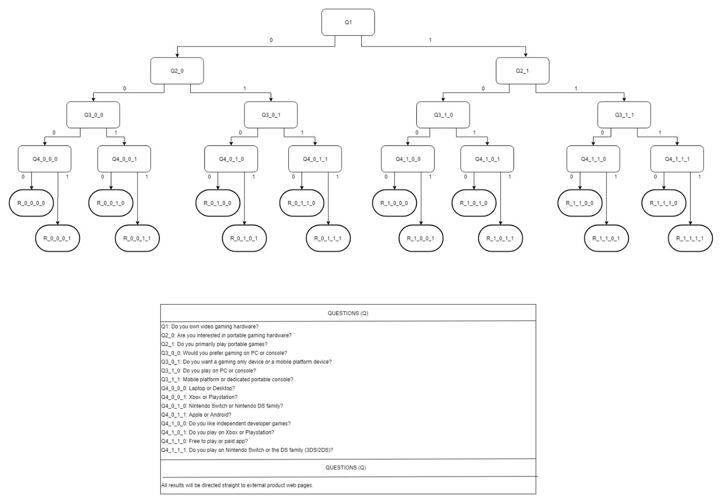

Below are the screenhots in order for one path of questions.